**IFT 266 Introduction to Network Information communication Technology (ICT)**

**Lab 47**

**IPv6 Troubleshooting**

Co-Authored by Joshua Brown

1. Open the file IPv6_Troubleshooting.pkt. Try pinging each computer. (PC1 → PC2, PC1→ PC3)

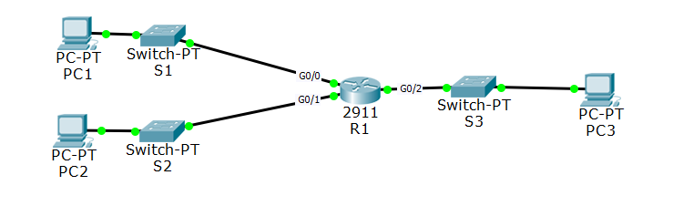



2. What do you notice is wrong with the topology?

PC 1 is on the wrong subnet. It is on Subnet B

Purpose of this lab is to troubleshoot the above network, figure out the problem and how to fix it.

Do not forget about the show commands!

3. What is causing the issue (s)?......Do not over think it. The cause is more obvious than you think!

Truthfully, it’s because they are in static and not autoconfigured. Removing the human element will remove mistakes. But because it is static, whoever assigned the IPv6 address to PC1 used the wrong subnet.

4. What did you do to fix the issues?

I changed the subnet from B to A

2001:DB8:AAAA:A:2E0:F7FF:FEC8:3436

_______________________________________________________________

**NOTE:** Do not use auto configuration to fix the problem.

5. Attach a screenshot of your two successful pings from PC1 → PC2 and PC1 → PC3 below.

